Case 2-ME-Syria-Inanna-Ishtar holding Jug-Horned Headdress-Terracotta-2100 BCE

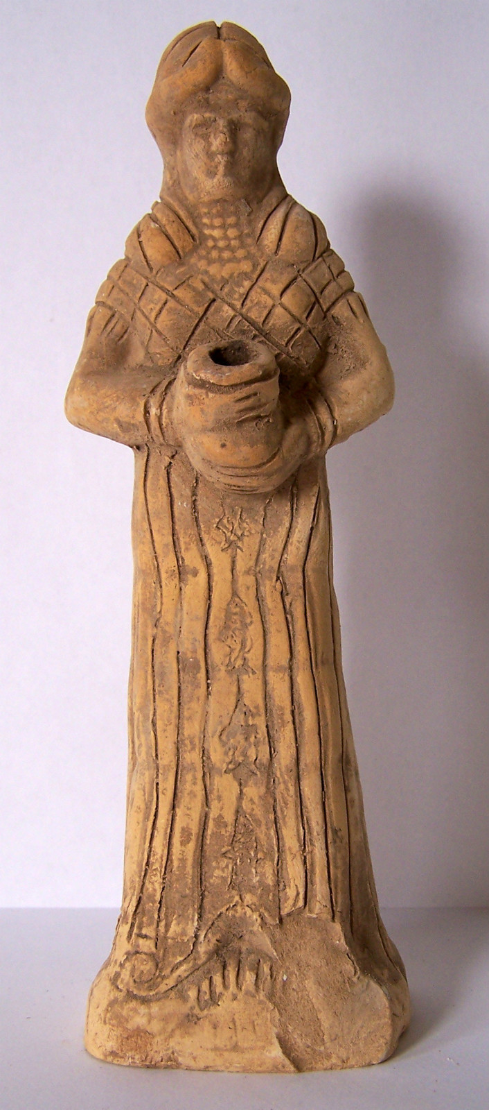 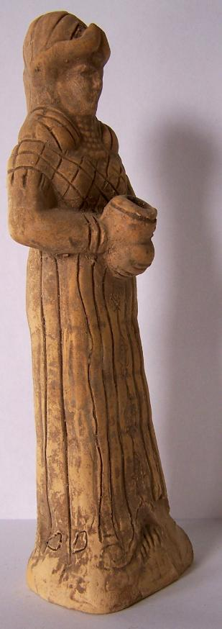

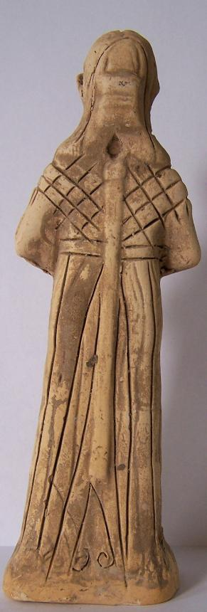

Case no.: 2

Accession Number:

Formal Label:

**Display Description:**

*Inanna and Enki* (ETCSL [t.1.3.1](http://etcsl.orinst.ox.ac.uk/cgi-bin/etcsl.cgi?text=t.1.3.1)) is a lengthy poem written in Sumerian, which may date to the Ur III period or the Neo-Sumerian Empire, ca 22nd to 21st century BCE, a short-lived territorial-political state. It tells the story of how Inanna stole the sacred [*mes*](https://en.wikipedia.org/wiki/Me_(mythology)) from Enki, the god of water and human culture (Kramer 1961: 66). In ancient Sumerian mythology, the *mes* were sacred powers or properties belonging the gods that allowed human civilization to exist.[[116]](https://en.wikipedia.org/wiki/Inanna" \l "cite_note-FOOTNOTEBlackGreen1992130-118) Each *me* embodied one specific aspect of human culture (Black and Green 1992: 130). In this votive statuette Inanna is holding the *me* of water that guarantees the life-giving fluid for the people of the earth, their crops and their animals. The original statue of Inanna depicted with her horned headdress denoting her as a goddess was found in Syria dating to 2100 BCE. On the front of her dress are the flowing waters of life with “the fish of the subterranean waters” swimming up from a subterranean cave (ETCSL t.1.3.1, sec. G).

**LC Classification:**

Date or Time Horizon:

Geographical Area:

**Map:**

**GPS coordinates:**

Cultural Affiliation:

Media:

Dimensions: H 18 cm x W 4cm

Weight:

Condition: original.

Provenance:

**Discussion:**

**References:**

Black, Jeremy; Green, Anthony (1992), [*Gods, Demons and Symbols of Ancient Mesopotamia: An Illustrated Dictionary*](https://books.google.com/?id=05LXAAAAMAAJ&q=Inana). London: The British Museum Press.

ETCSL. Nd. http://etcsl.orinst.ox.ac.uk/cgi-bin/etcsl.cgi?text=t.1.3.1#

Kramer, Samuel Noah (1961), [*Sumerian Mythology: A Study of Spiritual and Literary Achievement in the Third Millennium B.C.: Revised Edition*](http://www.sacred-texts.com/ane/sum/). Philadelphia, Pennsylvania: University of Pennsylvania Press.

| Shipping details |
| --- |
| **Ralph J Coffman Jr**  149 Atlantic Ave  Swampscott MA 01907-2427  United States |

## Order details

|  |  |  |  |
| --- | --- | --- | --- |
| **Item title** | **Available actions** | **Shipping & handling (estimated delivery\*)** | **Price** |

[Printer version](http://payments.ebay.com/ws/eBayISAPI.dll?ViewPaymentStatus&transid=0&userloginid=802-867&orderid=125303748018&printerversion=true&itemid=271104286471)

|  |  |  |
| --- | --- | --- |
| Seller: | [**Member id** antiquewd](http://myworld.ebay.com/antiquewd) ( [**Feedback Score Of** 1459](http://feedback.ebay.com/ws/eBayISAPI.dll?ViewFeedback&userid=antiquewd)) | [Contact seller](http://contact.ebay.com/ws/eBayISAPI.dll?ShowCoreAskSellerQuestion&frm=3998&iid=0&redirect=0&requested=antiquewd) |

|  |
| --- |
| **Order # 125303748018**  Paid on Nov-18-12 via PayPal |

**antiquewd**

[**Member id** antiquewd](http://myworld.ebay.com/antiquewd/&_trksid=p3984.m1439.l2754) | [**Feedback Score Of** 1459](http://feedback.ebay.com/ws/eBayISAPI.dll?ViewFeedback2&userid=antiquewd&_trksid=p3984.m1439.l2776) | 98.5%

**Total items :** 17

$541.62

+$40.00

shipping

**Roman style clay statue figure**



[Roman style clay statue figure](http://www.ebay.com/itm/360512451396?ssPageName=STRK:MEWNX:IT&_trksid=p3984.m1439.l2649) (360512451396)

Your max bid: $55.00

Sale date: 11/18/12

Tracking number: --

Estimated Delivery: 11/21/12 - 11/26/12

$22.72

**Paid with PayPal on November 18, 2012.**

**Not shipped**

**Feedback not left**

**Feedback not received**

|  |
| --- |
| [**Leave feedback**](http://feedback.ebay.com/ws/eBayISAPI.dll?LeaveFeedbackShow&useridto=antiquewd&item=360512451396&transactID=0&ssPageName=STRK:MEWNX:LF&_trksid=p3984.m1439.l2665) |
| [Sell this item](http://cgi5.ebay.com/ws/eBayISAPI.dll?SellLikeItem&item=360512451396&ssPageName=STRK:MEWNX:LILT&_trksid=p3984.m1439.l2667) |
| [More action](javascript:;) |